Benes network modules 2x2

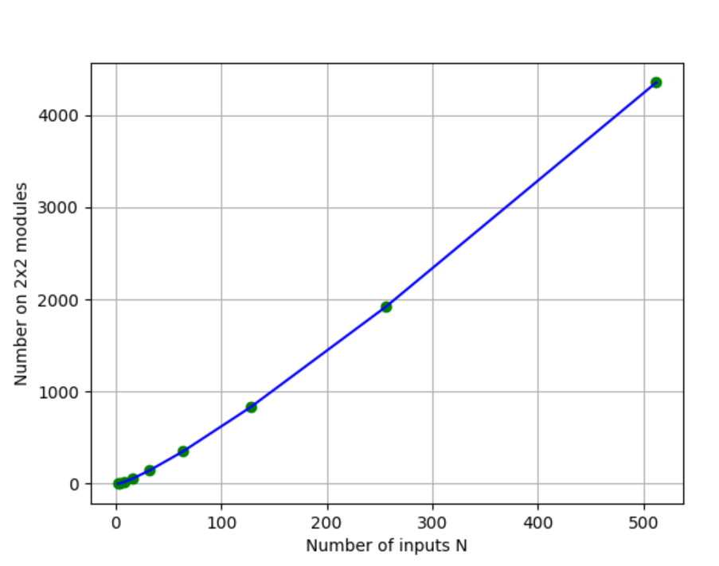

In my program, I ask user about N (inputs) and program gives output – numer of 2x2 modules.

Also, it draws graph for diffrent powers of 2, we can change powers in source code to change points on the graph.

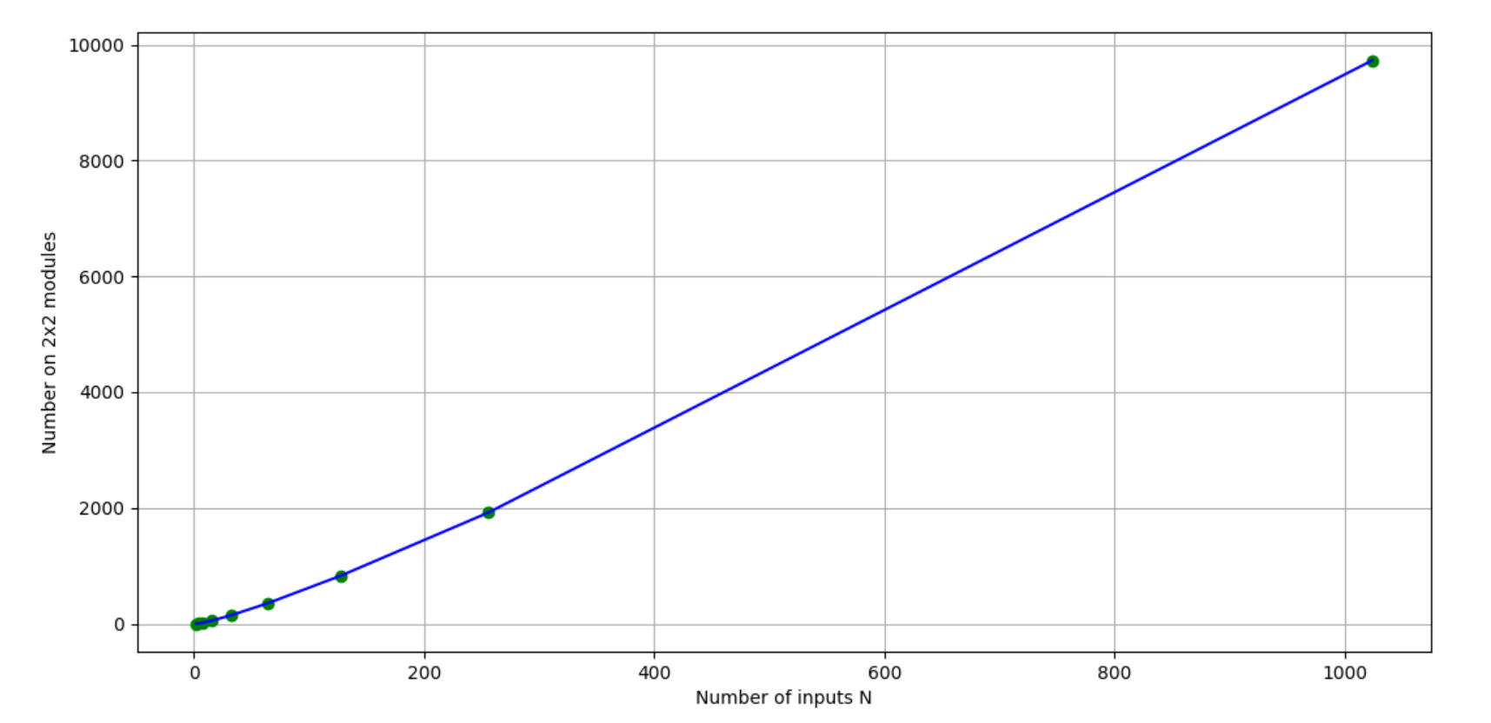

We can observe the n\*log(n) complexity.

To run program, find in the folder python file and click it. I used these libaries: math, numpy matplotlib.pyplot .